

**AMERICAN INTERNATIONAL UNIVERSITY–BANGLADESH (AIUB)**

**FACULTY OF SCIENCE & TECHNOLOGY**

**INTERNSHIP AFFILIATION REPORT ON**

**“Student Assistant” at**

**VUES (Virtual University & Expert System)-AIUB**

An Internship Report Presented to the

OFFICE OF PLACEMENT and

DEPARTMENT OF COMPUTER SCIENCE

In Partial Fulfillment of the Requirements for the Degree

***Bachelor of Science in Computer Science& Engineering***

**Supervised By**

MD.MASUDUZZAMAN  
Lecturer

Computer Science

Faculty of Science and Technology

American International University-Bangladesh

**Submitted By**

**Hassan Faria**

**ID: 16-31826-1**

Summer 2018-2019

Date of Submission: July 28, 2019

# LETTER OF SUBMITTAL

**MD.MASUDUZZAMAN**  
Lecturer

Computer Science

Faculty of Science and Technology

American International University-Bangladesh

**Subject: Submission of the Internship Report.**

Dear Sir,

It is a great pleasure to have the opportunity to submit my internship report on the experience gained during my internship period in **VUES** (Virtual University & Expert System) department at **American International University-Bangladesh (AIUB)**. I have prepared this report in accordance with the instructions given by you and the university. I expect this report to be informative as well as comprehensive.

Working in **VUES** was inspiring and a great learning experience for me. I hope this knowledge will facilitate me a lot in my future career endeavors. I have given utmost care to be as thorough as possible for preparing this report. I have tried my level best to prepare the report worthwhile.

I sincerely hope that this report meets your approval and demonstrate my ability to present internship report. I would be glad to present you with any clarification if required.

Yours sincerely,

-----------------------

Hassan Faria

ID: **16-31826-1**

Date: 28.07.2019

**LETTER OF ENDORSEMENT**

The Internship Affiliation Report entitled “Student Assistant at AIUB (American International University – Bangladesh)” has been submitted to the Office of Placement and Department of Computer Science in partial fulfillment of the requirements for the degree of Bachelor of Science (BSc.) in Computer Information System by Hassan Faria, ID: 16-31826-1. This report is presented to the Internship Defense Committee for evaluation and has been accepted.

------------------------------------------

**MD.MASUDUZZAMAN**

Internship Supervisor (academic)  
Lecturer

Computer Science

Faculty of Science and Technology

American International University-Bangladesh

(AIUB)

------------------------------------------

**DANILO G. MORGIA**

*Internship Supervisor (Industry)*

*Sr. Assistant Professor and Director, IT*

*Faculty of Science & Business Administration*

*American International University-Bangladesh (AIUB)*

-

-----------------------------------------

**Dr. Dip Nandi**

*Director*

*Faculty of Science & Information Technology*

*American International University –Bangladesh (AIUB)*

**ACKNOWLEDGEMENT**

First of all, I would like to thank Almighty, for his grace in accomplishing my internship report on time. I would like to express my gratitude to the **Faculty of Science & Information Technology** to keep internship credit in the curriculum of the graduation program and give me a scope of tasting the flavor of industry-oriented tasks and the field of work with my interest. I am also grateful to the **Faculty of Science & Information Technology & Office of Placement & Alumni**, AIUB to arrange an opportunity for choosing an own interested organization and complete internship there. In the procedure of accomplishing the report, the university itself and the internship supervisor **MD.MASUDUZZAMAN** deserve the gratitude as they have allowed me choose a company for internship according to my wish. I am also thankful to my organization supervisor **DANILO G. MORGIA** from the core of my heart for their kind support, guidance, constructive, supervision, instructions and advice and for motivating me to do my internship smoothly.

Finally, I would like to thank everyone who supported me is any respect for the successful realization of my internship, as well as expressing my apology that I could not mention personally one by one. I am pleased to complete the report on the given subject properly and authentically.

# TABLE OF CONTENTS

|  |  |  |
| --- | --- | --- |
| **TOPICS** | | ***Page no*.** |
|  | |  |
| 1. **Title Page** | | 1 |
| 1. **Letter of Submittal** | | 2 |
| 1. **Letter of Endorsement** | | 3 |
| 1. **Acknowledgement** | | 4 |
| 1. **Table of Content** | | 5 |
|  | |  |
| 1. **Introduction** | | 6 |
| * 1. Rationale | | 6 |
| * 1. Background | | 7 |
| * 1. Objectives | | 10 |
| 1. **Activities** | | 11 |
| * 1. Work Load | | 11 |
| * 1. Organization Wide | | 12 |
| * 1. Other Relevant Activities | | 13 |
| 1. **Constraints/Challenges** | | 14 |
| * 1. Identified/Observed in the Organization | | 14 |
| * 1. Academic Preparation | | 15 |
| * 1. Personal/Professional Skills | | 16 |
| 1. **Acquired Knowledge** | | 17 |
| * 1. Consequences to Organization | | 17 |
| * 1. Implications to University’s Internship Program | | 18 |
| * 1. Effects on Personal/Professional Skills | | 19 |
| 1. **Concluding Statements** | | 20 |
| * 1. Summary | | 20 |
| * 1. Recommendations/Suggestions for future strategic actions | | 21 |
|  |
| 1. **Recommendation Letters** | | 22 |
| 1. **References** 2. **Appendices** | | 23  24 |
|  | |  |

1. **INTRODUCTION**
   1. **Rationale**

The internship programs helped me a lot to learn about the practical situation of the organization. This program helped me to implement my theoretical knowledge into practical realistic environment. I can apply my practical knowledge in future when I will join any other organization. As a student of CIS department in American International University- Bangladesh, I have earned theoretical knowledge, which was not exactly same with the practical organizational environment.

The purpose of the internship program is to help students focus on their career interests and potentials. The whole program entitles to give the opportunity to learn, observe and determine their goals and aims. At the end of the period, the study allows them to gather information and construct a report on their observations, knowledge and experience. As stated earlier the study also assists students in completing their academic credit.

**Background: American International University – Bangladesh**

American International University - Bangladesh (AIUB) is a government approved private university founded in 1994 by Dr. Anwarul Abedin. The university is an independent organization with its own Board of Trustees. Dr. Carmen Z. Lamagna is the present Vice-Chancellor of the university. AIUB currently operates under four distinct faculties: Faculty of Arts and Social Science (FASS), Faculty of Business Administration (FBA), Faculty of Engineering (FE) and Faculty of Science and Information Technology (FSIT). AIUB ranked as an International University by UNESCO which is published by UNESCO in the International University Handbook, 2006 edition.

* + 1. **Vision**

AMERICAN INTERNATIONAL UNIVERSITY-BANGLADESH (AIUB) envisions promoting professionals and excellent leadership catering to the technological progress and development needs of the country.

* + 1. **Mission**

AMERICAN INTERNATIONAL UNIVERSITY-BANGLADESH (AIUB) is committed to provide quality and excellent computer-based academic programs responsive to the emerging challenges of the time. It is dedicated to nurture and produce competent world class professional imbued with strong sense of ethical values ready to face the competitive world of arts, social science and technology.

* + 1. **Goals**

Continue to upgrade educational services and facilities responsive of the demands for change and needs of the society.

▪ Inculcate professional culture among management, faculty and personnel in the attainment of the institution's vision, mission and goals.

▪ Enhance research consciousness in discovering new dimensions for curriculum development and enrichment.

▪ Implement meaningful and relevant community outreach programs reflective of the available resources and expertise of the university.

▪ Establish strong networking of programs, sharing of resources and expertise with local and international educational institutions and organizations.

▪ Accelerate the participation of alumni, students and professionals in the implementation of educational programs and development of projects designed to expand and improve global academic standards

* + 1. **Linkage & Networking**
* Microsoft Security Cooperation Program
* Microsoft IT Academy
* MSDNAA
* CCNA and IT Essentials in collaboration with CISCO
* Authorized Sun Education Centre
* Education Partner of Bangladesh Cricket Board
* Oracle Academy
* Certifies Internet Web (CIW) Professional Program
* CTP Authorized Training Academy
* The Duke of Edinburgh's International Award
  + 1. **Institutional Member**
* Asia Pacific Quality Network (APQN)
* International Association of Universities (IAU)
* International Association of University Presidents (IAUP)
* American Association of University Administrators (AAUA)
* Association of Universities of Asia and Pacific (AUAP - Board Member)
* Global University Network for Innovation (GUNI)
* Association of Management Development in South Asia (AMDISA)
  + 1. **Member**
* American Chamber of Commerce in Bangladesh (AmCham)
* Association of Management Development Institutions of Bangladesh (AMDIB)
  + 1. **Facilities at AIUB**

A university is a fountainhead of knowledge. New knowledge, skills and meaningful experiences spring from the university. To quench the thirst of individuals who are in search for wider horizon of learning and discover novel challenges in life is the inherent intention of AIUB even at the time of its conception. Students are honed and nurtured to become Leaders in their respective chosen discipline. It continuously transforms students into active participants in the development process in both curricular and extra-curricular activities. It has built and maintained its reputation as a leader in the pursuit of quality and excellence. The primary beneficiaries are the students who stand to benefit from all the resources and services provided by the university. Under the stewardships of dedicated and visionary founders, dynamic management, competent faculty and skillful support staff, the university continues to be the venue for change and producing leaders in various arenas of endeavors. To cope with the demand of the times and the needs of the learners, the university is backed up with adequate state facilities:

* Concerned for quality output
* Internationally affiliated institution
* World Class State-of-the-art facilities
* Full time faculty with adequate academic and professional exposure
* Qualified and accommodating academic and non-academic staff
* Medium of instruction is English
* Located in a serene part of the cosmopolitan city
* Friendly and exciting campus life
* Guidance and counseling services
* Fully air-conditioned library with regularly updated collection of reference books, journals and periodic.
* On campus cafeteria
* Air-conditioned class rooms with audio-visual facilities
  + 1. **Laboratory facility**

American International University has modern laboratory facilities. The university has Physics Lab, Chemistry Lab, Language Lab, Computer Lab, Multimedia Lab, Architecture Studios and some others Labs as well.

* 1. **Objectives**

This internship report is prepared primarily to fulfill the Bachelor of Science (B. Sc.) in Computer Information System (CIS) degree requirement under the Faculty of Science & Information Technology (FSIT). The purpose of the internship program is to help students focus on their career interests and potentials. The whole program entitles to give the opportunity to learn, observe and determine their goals and aims. At the end of the period, the study allows them to gather information and construct a report on their observations, knowledge and experience. It helps to gain knowledge of professional environment and prepare for future career. As stated earlier the study also assists students in completing their academic credit.

**2. ACTIVITIES**

**2.1 Work Related**

My main responsibilities were to assist the head of IT-operations in his day to day activities,

such as:

* Documentation of AIUB website [(http://www.aiub.edu/](http://www.aiub.edu/))
* Upload Notices, News & Events to different departments website approved by department coordinator.( ex. [`http://fass.aiub.edu/,](http://fass.aiub.edu/) <http://mmc.aiub.edu/>)
* Assisting the faculty on their requests.
* Providing support to student all requirements.
* Maintain documentation related to faculty and students.
* Help to prepare pre-registration and registration for upcoming semester.
* Assist in encoding the courses and documents in UMS (university management system)

**Convocation:**

A student officially finishes his\her academic degree through convocation. IT operations have the following tasks to perform before a student can be cleared for convocation.

1. Mapping student’s grades
2. Checking curriculums of the student
3. Checking accounts of the student
4. Checking waiver, dropping, invalid subjects and their grades.

All of the above process is performed as per the policy set by the university.

**Registration:**

Registration is one of the important tasks of any University. It is the process through which any student gets enrolled in to a new semester. Registration process in AIUB can be divided in to two parts:

1. Freshmen enrollment
2. Enrollment of existing student in to a new semester

For both the process to perform, the IT operations of AIUB have quite some tasks to perform like:

1. Creating code number, timing, room number and capacity for individual sections in the system.
2. Encoding those code number, timing, room number and capacity in the system.
3. 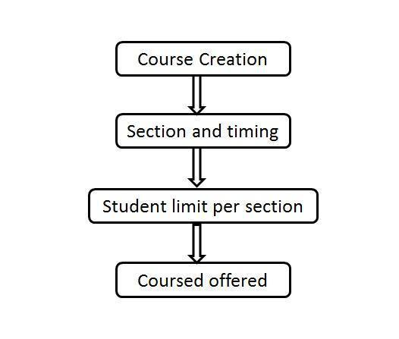Increasing capacity limit of each class upon request from the department head as per university policy.

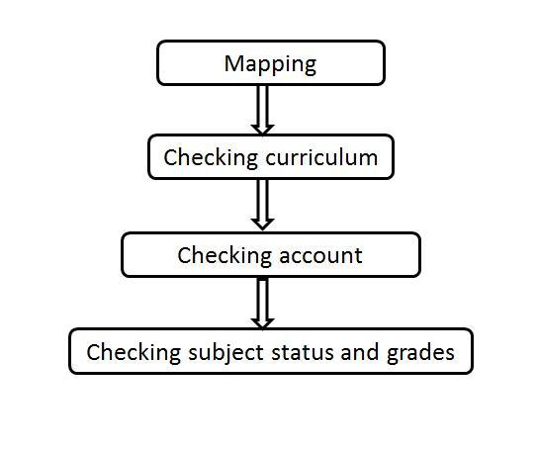

**Fig: Course offering for registration Fig: Convocation clearance steps**

**2.2 Organization- Wide**

* ID Card Distribution
* Distributing Exam Permit
* Course creation, section, timing , course offered
* Course Dropping and scanning documents
* Project and Thesis group Creation and student Allocation
* Convocation Clearance

**2.3 Other Relevant Activities**

While my time working in the VUES there were times when I needed to learn new things to keep up with all the works that are done here. Among them were

* Keeping back up of the distributed certificates.
* Adding late fines to student accounts.
* Deleting fines from student’s accounts.
* Keeping back up of dropped subjects in student accounts.

**3. CONSTRAINTS/CHALLENGES**

**3.1Identified/Observed in the Organization**

The workflow of VUES operations is very much dependent with other departments of AIUB so there should be proper coordination among each and every department otherwise it really becomes a tough time for VUES to run its operations smoothly within the given time frame by the management.

Frequent update of UMS without prior notification is another hassle which we are facing now-a-days. In this case prior notification can be the solution of this problem.

Sometimes hardware division stop the server for maintenance than whole operations are withheld.

Again, we process the printing of ID cards and certificates, often the machine creates problem, and the vendors providing the service for maintenance do not response to our request as per our requirements. This problem can be solved if there is a written agreement between us and the vendors.

Inappropriate distribution of work load is another problem which we are facing now-a-days. This problem can be solved in two ways; by hiring more employees or transferring some of many entry level tasks to other departments.

* 1. **Academic Preparation**

There lies a vast difference between the students and wh

o stand in front of them to teach and help them to learn. During this internship affiliation, the learning’s at my Web technology course have helped me a lot to support the students to complete their tasks in the lab classes. Sometimes, I needed to revise the course materials before the classes. It helped me a lot to recapitulate what I have learnt earlier which made my knowledge base strong for the future.

* 1. **Professional Skills**

Most of the works in VUES is static work which doesn’t require any programming as a result there is very little room for a CS student to grow his programming knowledge here. And the work environment represents more of a traditional office environment opposing to the work environment of the software industry. The main challenge for an intern student here which represents a traditional office environment are the following

* No work related to programming.
* No interaction with buyer or customer.
* Very little room for creative work.
* No room for innovative work.
* No competitive work environment.
* No room to grow skills required in the software industry.
* No room for showing programming skills.

1. **ACQUIRED KNOWLEDGE**

**4.1 Consequences to Organization:**

It was a great experience to work under Director of IT-operations, AIUB. This helped to me to improve my technical and analytical skills. It was hard and challenging for me to adapt with this new environment. Although it is always difficult and challenging to learn new things, but I think that, I was able to cope with these challenges. As I was always passionate and eager improve my interpersonal skills, it did not take time for me to learn and accustomed with new surroundings.

**4.2 Implications to University’s Internship Program:**

This internship is a part of the academic program. AIUB has given me this opportunity to have a practical job experience before getting into a permanent job as a full-time employee. The internship has improved my skills a lot in jobs real life where I need it every time and every step. As a student of AIUB I was not that much worried about getting an internship, because I always heard that this university has a great reputation in corporate world. In real scenario I have observed that they do not have enough reputation to confirm every student’s internship in any reputed organization without any difficulties. Perhaps they can build this reputation in corporate world by doing different types of activities like, arranging different types of seminars by inviting the reputed organizations. As a result, student’s tension about not getting any internship will remove and will be able concentrate more on internship report. University can negotiate with several companies who will be agreeing to take the responsibility of intern students of AIUB. I have learned formal report format. Acquisition of academic information and practical job information from different sources help me to prepare the report.

I have also learned few more things through this internship program like-

* I learned how to follow supervisor instructions strictly.
* How to follow the guideline of an affiliation report for the internship.
* How to present work experience in the report.
* I have observed the way of communication.
* Learned to be respectful to rules and regulation.
* It has improved my trust, confidence and professionalism.
* It has increased my timeliness and regularity in work.
* Developed my skills and competencies.
* I maintain strict discipline in my university that helps me to maintain bank’s discipline.
* I learned difference between academic lessons and professional work.

**4.3 Personal/Professional Skills:**

**Experience:**

An internship provides valuable experience. It helps me gaining a better understanding of the likes, dislikes, and wants for the future career. It also gives me valuable hands-on experience and allows these to apply what I have learned in internship period to a certain career field

**Punctuality:**

An employee who is punctual is considered as credible in the eyes of his/her employer. From my internship, I have learned to be more punctual because there was fixed time limit for me, so I had to prepare myself according to that time schedule and took necessary preparations. It helps me to organize my work well, thinks ahead of time, prioritizes the given tasks and is overall successful.

**Time management:**

My time management started with setting priorities and organizing the internship period around the most important tasks. I had to finish my assigned task within a time frame. I needed to synchronize myself that way, so that I can finish my task in time. Effective prioritizing is about arranging workload based on both the importance of the tasks as well the resulting impact of the completed tasks.

**Confidence:**

Though at the beginning, I had little confidence on me but after completing my internship, it turned me to be more confident about the handling of student’s problems. Now I can apply this experience if I get a chance to build up my career in academic field.

**5. CONCLUDING STATEMENTS**

**5.1 Summary**:

The internship gives me the opportunity to be confident and habituated with the techniques which I will be able to apply in my future profession. It aided me to take new technological challenges and to give my level best to face that situation. I learned from my internship that how to deal with different person (students & faculties). I’ve learned how I should deliver myself to other so that everyone can get my point and work under pressure.

From my internship, I perceived these qualities in me; enthusiasm, imagination, patience, energy, adaptability, responsibility. I tried to establish a good working relationship with my supervisor and my peers; I made effective relationships with the students which helped me to understand their problem easily.

**5.2 Recommendations/Suggestions for future strategic actions:**

Internships offer students a period of practical experience in the industry relating to their field of study. This experience is valuable to students as a means of allowing them to experience how their studies are applied in the real world.

* + 1. **Organization:**

An organization should give opportunity to an intern where they can work in their interested area with potentiality rather than assigning a minor work.

* + 1. **University:**

An internship provides a great opportunity for prospective employees to gain experience in a particular field or industry, determine if they have an interest in a particular career, create a network of contacts, or gain university module credits. As the internship course is in the course curriculum of AIUB, I feel proud to be a student of AIUB. I would like to convey my thanks to Institute of Information Technology for providing me an opportunity to prepare myself for the competitive environment in the professional field. It has certainly boosted my coding skills. I now look forward to facing the upcoming challenges of the world.

* + 1. **Professional:**

Internships are also very useful to interns themselves as they offer the chance to find out what working for a particular company, or within a certain industry, are really like. There are some typical challenges that interns usually face: time management is a challenge. Others find that motivating students is an issue. Whatever the issue, it is important to take the best knowledge from the internship.

* 1. **RECOMMENDATION LETTER**

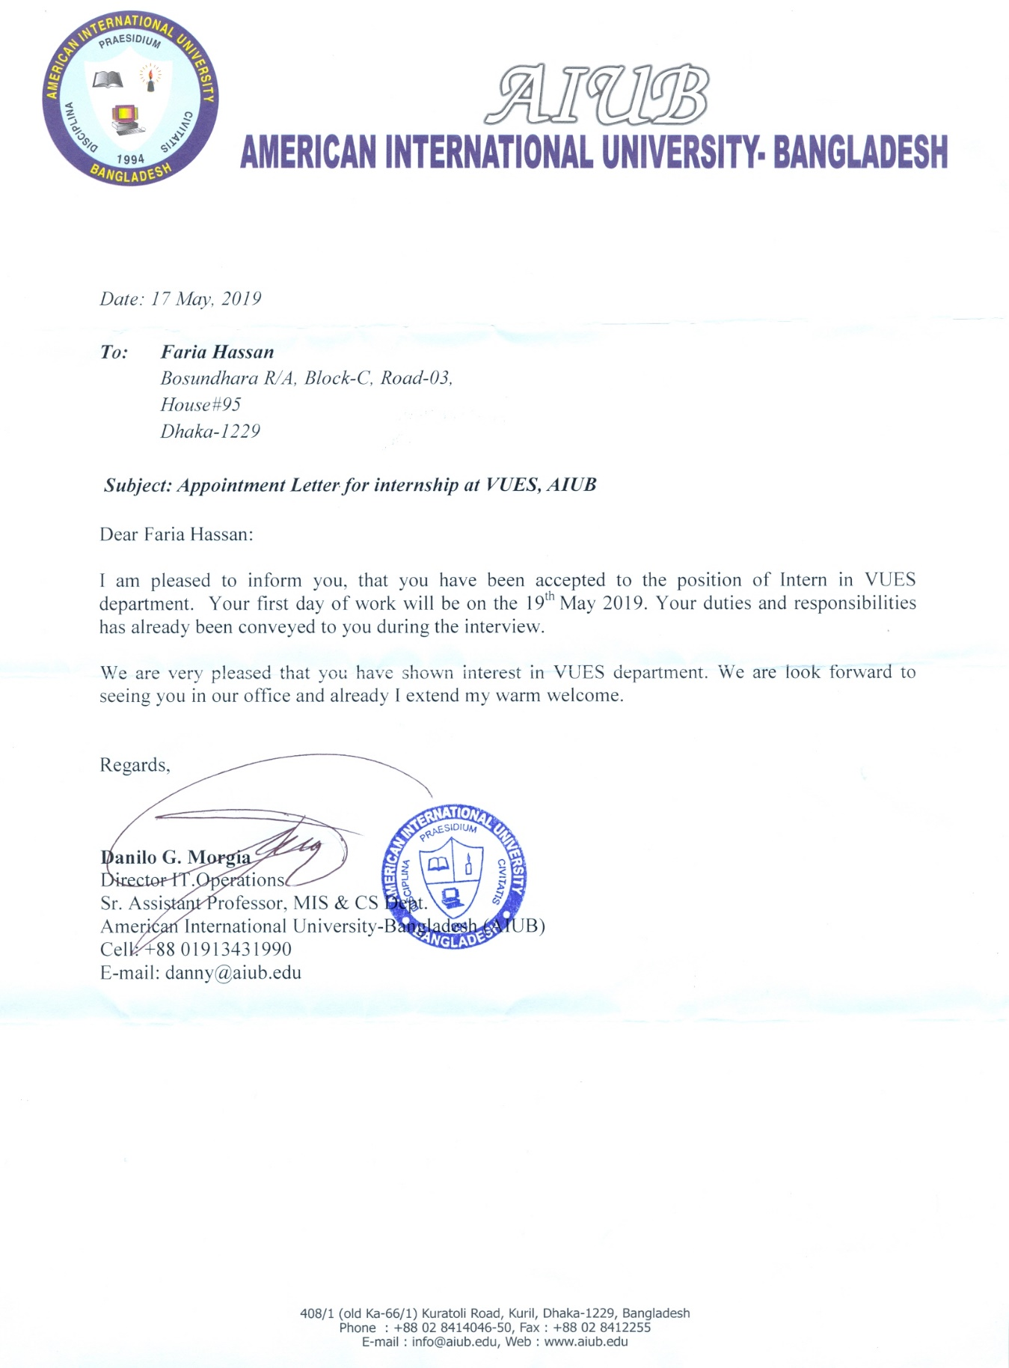

* 1. **REFERENCES**

The following sources were used to collect information for preparing this report:

<http://www.aiub.edu/>

<http://www.aiub.edu/about/information>

<http://www.aiub.edu/about/general-information>

<http://www.aiub.edu/about/why-study-here>

<http://www.aiub.edu/about/resources>

<http://www.aiub.edu/faculties/faculty-list>

* 1. **APPENDICES**

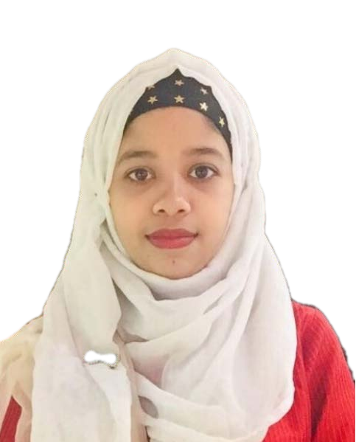**FARIA HASSAN**

(B.Sc,AIUB)

Phone No: 01631799932

Email: [fariahassan15@gmail.com](mailto:dasmandira588@gmail.com)

# Career Objective:

To pursue a highly regarding career in the area of software quality assurance, seeking for a job in challenging and healthy work environment where I can learn skills and gain knowledge from the organization.

# Educational Background:

|  |  |  |  |  |
| --- | --- | --- | --- | --- |
| Name  of the Degree | Subject | Institution | Result | Passing Year |
| B.Sc  (Hons) | Computer Science & Engineering | American International University-  Bangladesh(AIUB) | CGPA 3.52/4  .00 | 2019 |
| H.S.C. | Science | Muminunnesa Govt. Women’s College,Mymensingh | GPA 5.00/5  .00 | 2013 |
| S.S.C. | Science | Vidyamoyee Govt. Girls’ High  School,Mymensingh | GPA 5.00/5  .00 | 2011 |

**COMPETENCY:**

I am very much confident to work with people and able to keep control in pressure situations, enjoy working alone or in group to meet challenging target ambitions.

# COMPUTER SKILLS:

Efficient in Microsoft Office program like MS Word, MS Excel, MS PowerPoint.

# LANGUAGE PROFICIENCY:

Good command in both Bengali and English languages.

# SKILLS:

Skilled in Manual Testing, SikuliX Automation Testing, HTML5, CSS, C, C++

# PERSONAL INFORMATIONS:

NAME: Faria Hassan

Father's Name: Mother's NAME: Date of BIRTH: GENDER:

Nawab Hassan

Afroza Hassan

1st December, 1997

Female

Nationality: Bangladeshi

Present Address: House No: 95, Block: C Road: 3, Bashundhara R/A, Dhaka, Bangladesh.

**References:** MD.Masuduzzaman

(MSCS, B.SC)(AIUB)

Lecturer, American International University-Bangladesh (AIUB) Mob: 01818411757

[Email:masud.prince@aiub.edu](mailto:masud.prince@aiub.edu)

**Mohaimen Bin Noor**

(MSCS, B.SC)(AIUB)

Lecturer, American International University-Bangladesh (AIUB) Mob: 01716661799

[Email:mohaimen.niloy@aiub.edu](mailto:masud.prince@aiub.edu)